**Computer Networks LAB-1: Introduction to Packet Tracer, Peer-to-Peer Communication, Study of Cables and its Colour Codes**

**Objective**:

* To familiarize students with Cisco Packet Tracer.
* To set up a peer-to-peer (P2P) communication network.
* To study different types of network cables and their color codes.
* To document the observations and save the configuration file in a GitHub repository.

**Requirements**:

* Cisco Packet Tracer software.
* A GitHub account and a repository for lab assignments.
* Access to Google Classroom for submission.

**Instructions:**

**Part 1: Introduction to Packet Tracer**

* Ensure you have Cisco Packet Tracer installed on your computer. If not, download it from the Cisco Networking Academy website.
* Open Packet Tracer and explore the user interface. Familiarize yourself with different tools and components available in the software.

**Part 2: Peer-to-Peer Communication Setup**

* Open Packet Tracer and create a new network.
* Add two PCs to the workspace.
* Use a copper straight-through cable to connect the FastEthernet0 port of PC0 to the FastEthernet0 port of PC1.
* Assign IP addresses to both PCs:
* PC0: IP address: 192.168.1.1, Subnet Mask: 255.255.255.0
* PC1: IP address: 192.168.1.2, Subnet Mask: 255.255.255.0
* Open the command prompt on PC0 and ping PC1 using the command ping 192.168.1.2.
* Take a screenshot of the successful ping results.

**Results:**

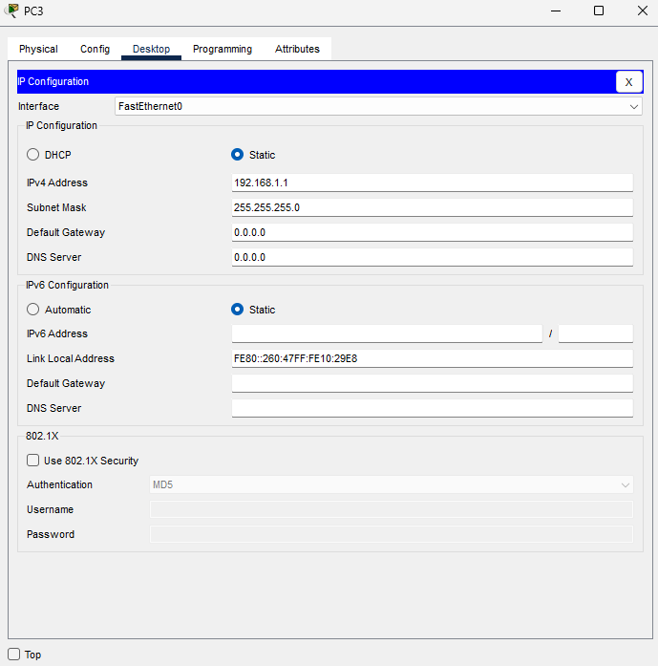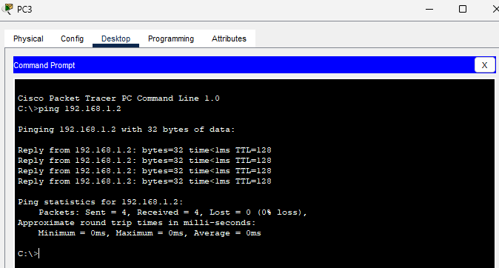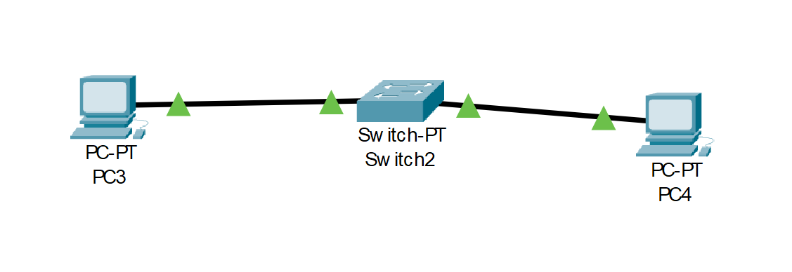

**Study of Network Cables and Color Codes**

**Types of Network Cables in Computer Networking**

1. **Copper Cables**
   * **Straight-Through Cable**
     + Purpose: Used to connect different types of devices, such as a computer to a switch or a switch to a router.
     + Structure: The wiring is consistent on both ends of the cable, meaning Pin 1 is connected to Pin 1, Pin 2 to Pin 2, and so on.
     + Common Use: Connecting a computer to a network device like a hub, switch, or router.
   * **Crossover Cable**
     + Purpose: Used to connect similar devices directly, such as connecting two computers or two switches without a hub or switch.
     + Structure: The wiring is crossed on the ends of the cable, where Pin 1 is connected to Pin 3 and Pin 2 to Pin 6.
     + Common Use: Connecting two similar network devices directly, such as PC-to-PC or switch-to-switch.
   * **Shielded Twisted Pair (STP) Cable**
     + Purpose: Provides more protection against electromagnetic interference (EMI) and crosstalk.
     + Structure: Similar to UTP but with an additional shielding layer.
     + Common Use: Environments with high EMI, such as industrial settings or places with many electronic devices.
   * **Unshielded Twisted Pair (UTP) Cable**
     + Purpose: The most common type of copper cable used in networks, without additional shielding.
     + Structure: Consists of pairs of wires twisted together.
     + Common Use: General network cabling, including both straight-through and crossover cables.
2. **Fiber Optic Cables**
   * **Single-Mode Fiber (SMF)**
     + Purpose: Used for long-distance communication, typically in telecom networks.
     + Structure: Uses a single strand of glass fiber to carry data via light waves.
     + Common Use: Long-distance data transmission, such as between buildings or across cities.
   * **Multi-Mode Fiber (MMF)**
     + Purpose: Used for shorter distances, like within a building or between buildings on the same campus.
     + Structure: Uses multiple light paths to carry data, allowing for more data to be transmitted over shorter distances.
     + Common Use: Data centers, LAN backbones, and other short-distance applications.

**Standard Color Codes for Copper Straight-Through and Crossover Cables**

**Straight-Through Cable (TIA/EIA-568-B Standard):**

* Pin 1: White/Orange
* Pin 2: Orange
* Pin 3: White/Green
* Pin 4: Blue
* Pin 5: White/Blue
* Pin 6: Green
* Pin 7: White/Brown
* Pin 8: Brown

**Crossover Cable:**

* **End 1 (TIA/EIA-568-B Standard):**
  + Pin 1: White/Orange
  + Pin 2: Orange
  + Pin 3: White/Green
  + Pin 4: Blue
  + Pin 5: White/Blue
  + Pin 6: Green
  + Pin 7: White/Brown
  + Pin 8: Brown
* **End 2 (TIA/EIA-568-A Standard):**
  + Pin 1: White/Green
  + Pin 2: Green
  + Pin 3: White/Orange
  + Pin 4: Blue
  + Pin 5: White/Blue
  + Pin 6: Orange
  + Pin 7: White/Brown
  + Pin 8: Brown

**Purpose and Use Cases of Each Type of Cable**

1. **Straight-Through Cable:**
   * Purpose: Primarily used for connecting different types of devices within a network.
   * Use Cases: Connecting computers to switches, switches to routers, or computers to hubs.
2. **Crossover Cable:**
   * Purpose: Enables direct communication between two similar devices without an intermediary device.
   * Use Cases: Directly connecting two computers, two switches, or two routers for data transfer.
3. **Fiber Optic Cables:**
   * **Single-Mode Fiber (SMF):**
     + Purpose: For high-speed, long-distance data transmission.
     + Use Cases: Telecommunications, connecting different buildings within a campus, or connecting cities.
   * **Multi-Mode Fiber (MMF):**
     + Purpose: For high-speed data transmission over shorter distances.
     + Use Cases: Data centers, LAN backbones, and other applications where high bandwidth over shorter distances is required.